Experiment - 5
Operating Systems Lab
Syeda Reeha Quasar
14114802719
6C7
AIM
To write the following shell programs:
- Script to check whether given string is palindrome.
- A script to calculate the average of n numbers.
- Script to find the sum of digits of a given number.

EXPERIMENT – 5

Aim:
To write the following shell programs:
- A script to check whether the given string is a palindrome.
- A script to calculate the average of n numbers.
- A shell script to find the sum of digits of a given number.

Source Code:

- A script to check whether the given string is a palindrome:

echo "Enter a String"
read input
reverse=""

len=${#input}
for (( i=$len-1; i>=0; i-- ))
do
reverse="$reverse${input:$i:1}"
done
if [ $input == $reverse ]
then
echo "$input is palindrome"
else
echo "$input is not palindrome"
fi

Output:
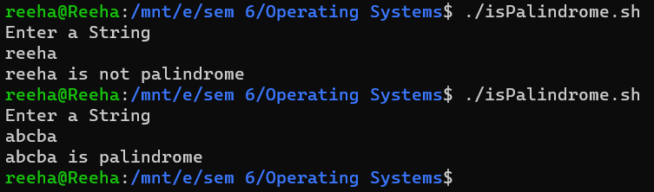

2. Write a script to calculate the average of n numbers

echo "Enter Size(N)"
read N

i=1
sum=0

echo "Enter Numbers"
while [ $i -le $N ]
do
read num #get number
sum=$((sum + num)) #sum+=num
i=$((i + 1))
done

echo "Average of given $N numbers is: "
avg=$((sum / N))
echo $avg

Output:

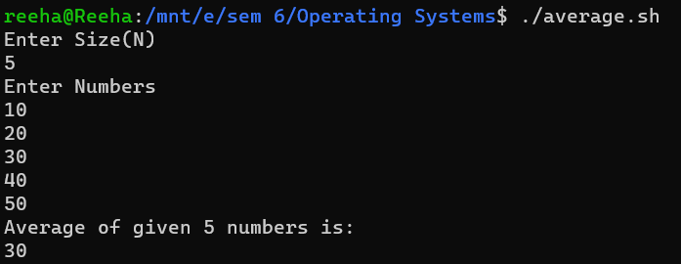
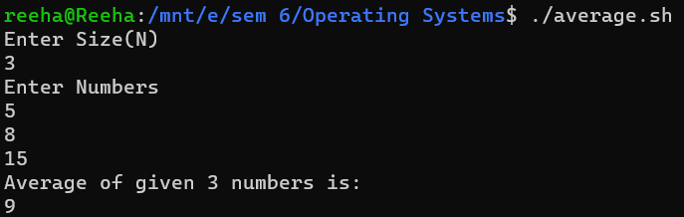

3. Write a shell script to find the sum of digits of a given number:

echo "Enter a number"
read num

sum=0

while [ $num -gt 0 ]
do
mod=$((num % 10)) #It will split each digits
sum=$((sum + mod)) #Add each digit to sum
num=$((num / 10)) #divide num by 10.
done

echo $sum

Output:

